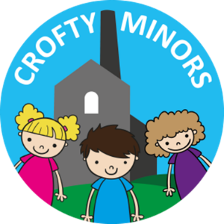
Home Learning sheet.
Pre-schoool 2020

- Go on a listening walk. What can you hear? Ask a grown up to make a list. You might hear cars, birds, people, doors slamming, a dog barking. Can you try to make those noises with your body?
- Sing some nursery rhymes with your children such as “Wind the bobbin up” or “Incy wincy spider”. Children love singing and joining in with the actions.
- Share stories together. Talk about the characters in the story.
- Draw your favourite animal and tell an adult what you know about them.
- Draw your favourite character from a story. Will it be Goldilocks, the Troll or the Big, bad, wolf?
- Draw some waves/circles/crosses/stars/triangles/spirals/straight lines
- With an adult carefully use scissors to cut paper. Be careful with your fingers remember!
- Colour in a picture of your favourite animal, transport or flower.
- Find a plastic cup or bucket and a paintbrush and paint the ground outside with water. Can you draw some animals or even write your name?
- Build a tower the same height as you with blocks/tins/books.
- Watch your favourite tv programme and talk about it with an adult.
- Count with your children during daily activities such as when walking around the house, cleaning your teeth or even washing your hands!
- Use the park hunt checklist to look around your local park/ field for the certain items. Can you find them all? Count them as you find them.
- Draw around both hands. How many fingers? How many thumbs?
- Draw around your feet. How many toes?
- Count all the socks in your bedroom. Muddle them up. Can you find the pairs? Match them up.

